# Workshop: Blog

This document defines the **workshop** assignment for the [Databases Advanced - Entity Framework course @ SoftUni](https://softuni.bg/trainings/4234/entity-framework-core-october-2023)

The 2000s called and said that blogging is back! You like to keep up with the trends and decide to create your own blog.

Knowing some of the **best practices** for building an app that uses a database, start working on the project. Below are the images, which demonstrate how the app should look like. The needed entities are described below as well. Keep in mind that all of the properties are **required**.

It's up to you to decide what approach to use. Don't forget what a blog's functionalities are:

* You can **register/login/logout**;
* You can **see all** of the posted articles and check their details;
* You can **edit** and **delete** **only** the articles that **you** have **created**.

Feel free to implement whatever patterns you feel most comfortable with. If you want, you can add some other functionalities.

## Entities

### Article

* **Id** (**int**, primary key)
* **Title** (**string** with length **[10…50]**)
* **Content** (**string** with length **[50…1500]**)
* **CreatedOn** (**DateTime**)
* **Author** (**string**)

### ApplicationUser

* **Id** (**string**, primary key)
* **UserName** (**string** with length **[5…20]**)
* **Email** (**string** with length **[10…50]**)
* **Email** (**string** with length **[5…20]**)

## Pages

If you are having trouble with the view files, you can use the ones from the Resources.

### Home

This what the "Home" Page should look like.

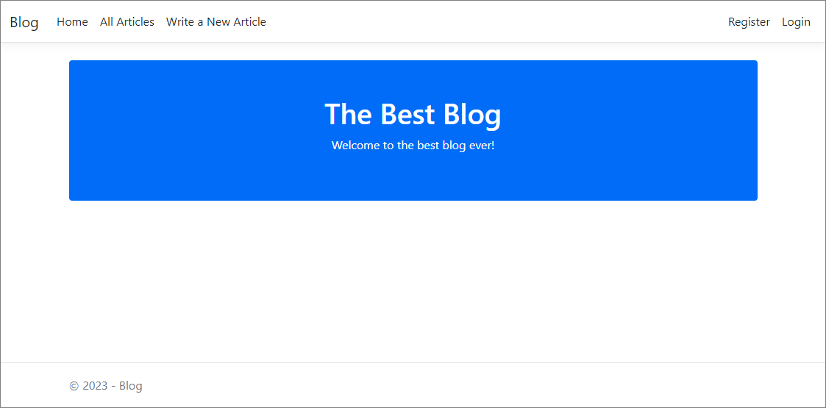

### Add Article

This is how the "Create a New Article" Page should look like.

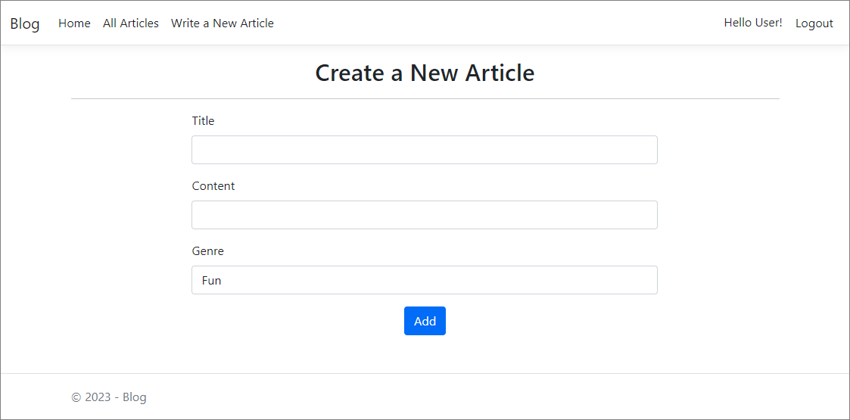

### All Articles

This is how you should visualize the list of articles.

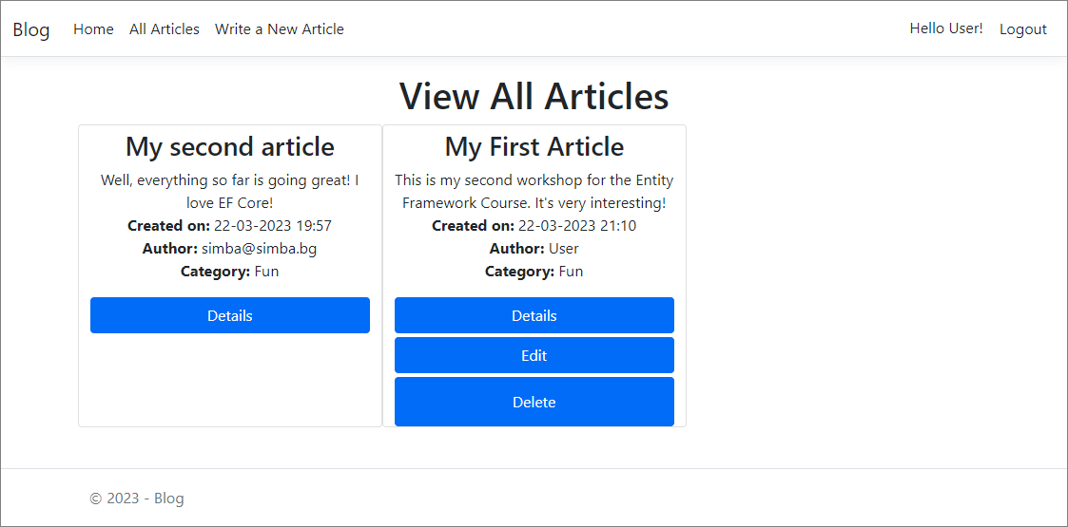

### Edit Article

This is how the "Edit Article" Page should look like.

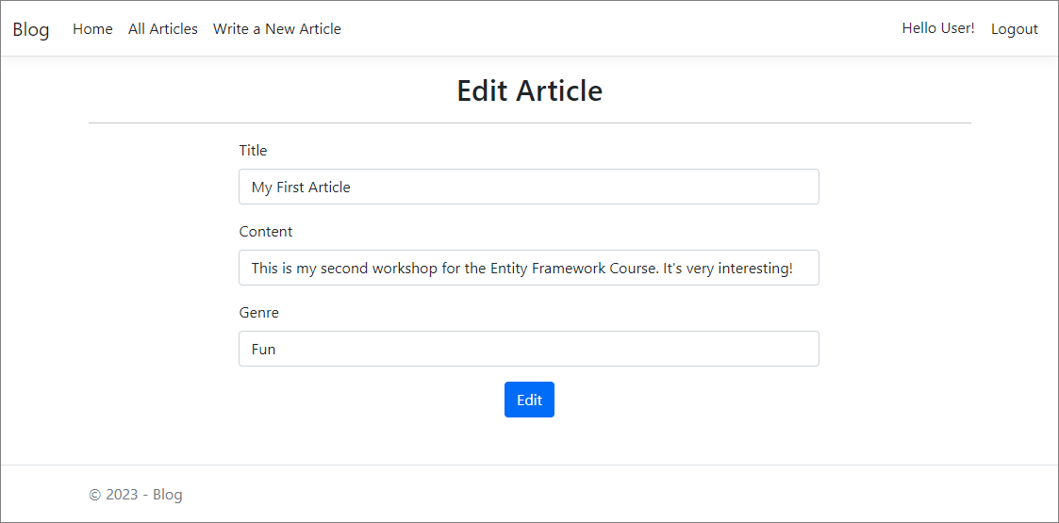

### Delete Article

You should be able to delete an event.

### Details

#### When you're the author

This is what the "Details" Page should look like, in case you are the author of the article.

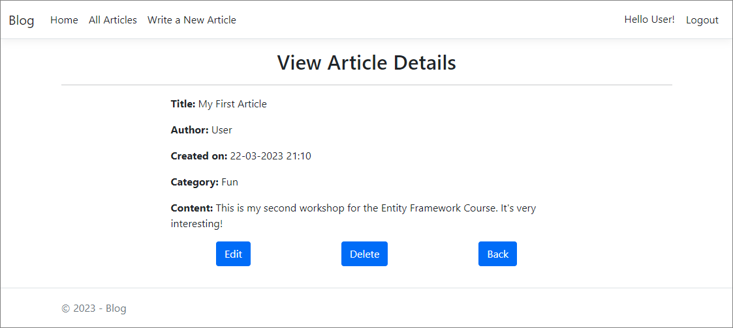

#### When you aren't the author

This is what the "Details" Page should look like, in case you are not the author of the article.

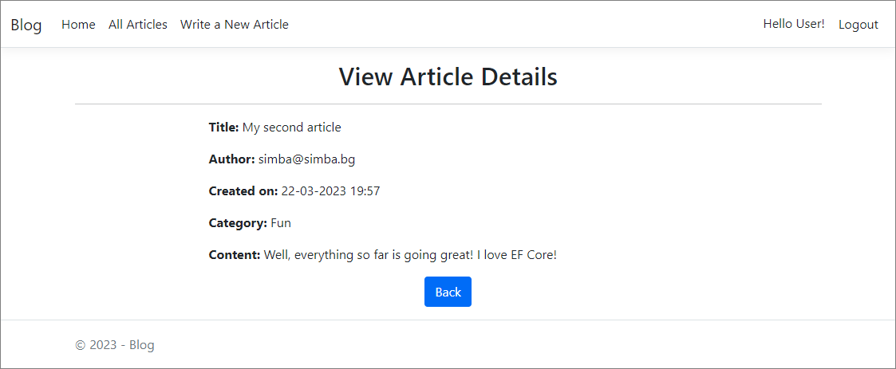

### Register

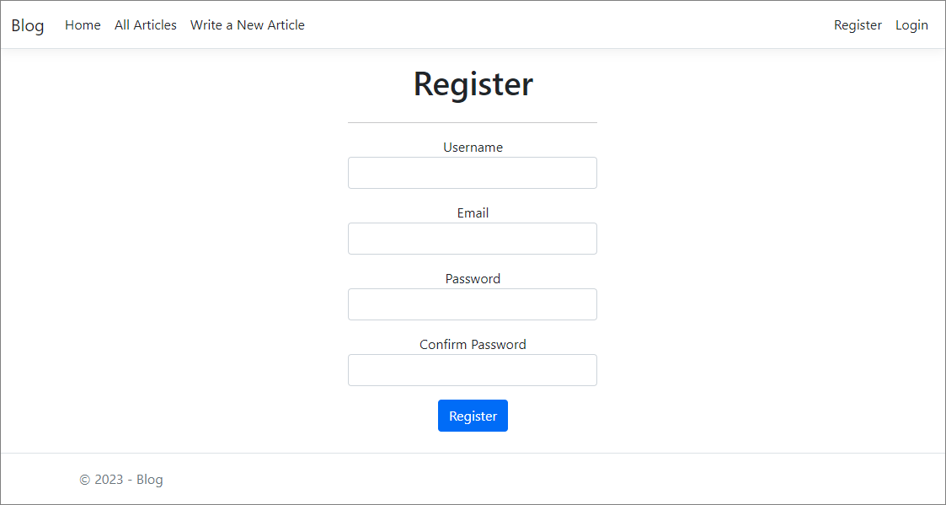

### Login

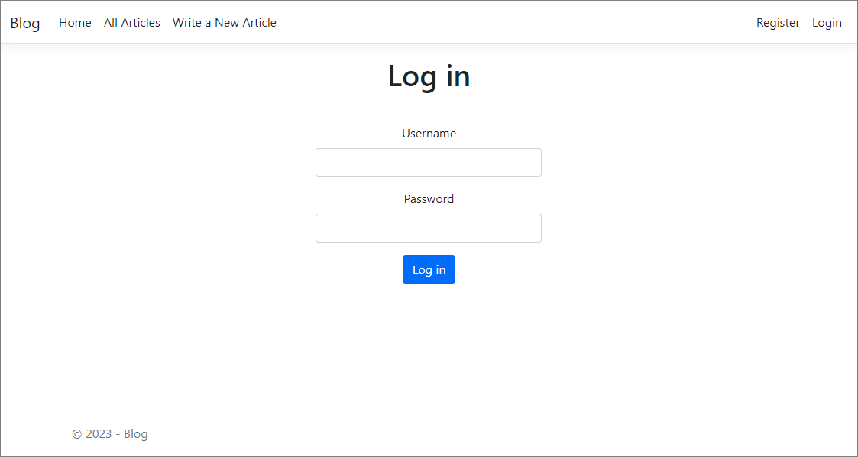

## Functionality

The app users should be able to view all of the articles, add new ones, delete and edit only created by them articles. If you want, you can try to implement some other functionalities.

**Happy Coding! 😊**